Case Study

on AWS VPC

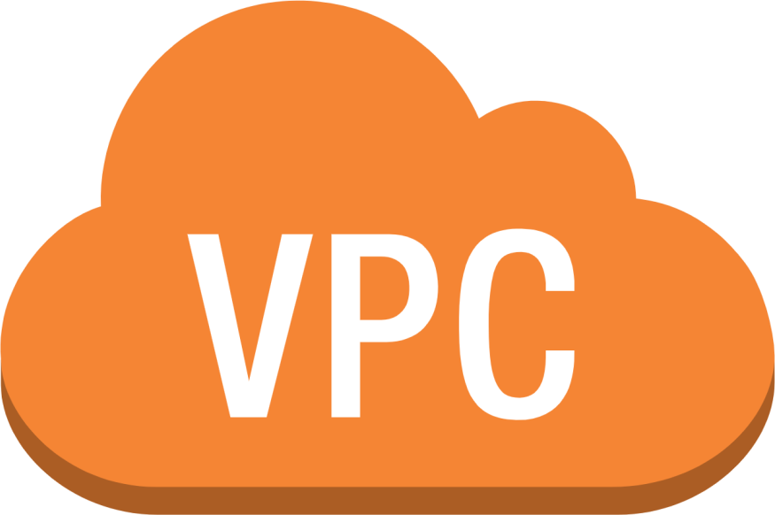

Note: For the theory portion see PPT on VPC

HANDS ON

**Step 1:** search vpc on management console and click on vpc .You will get the below interface then click on your VPC.

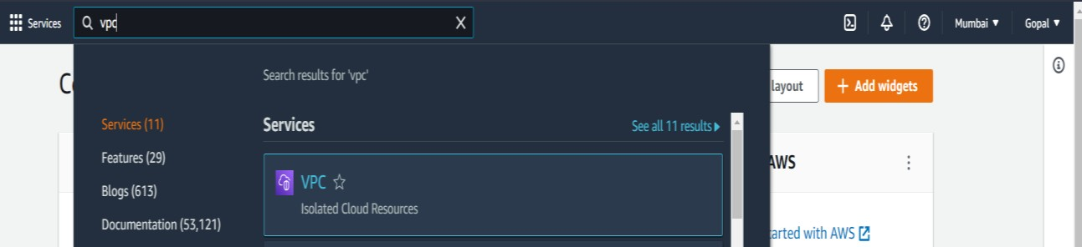

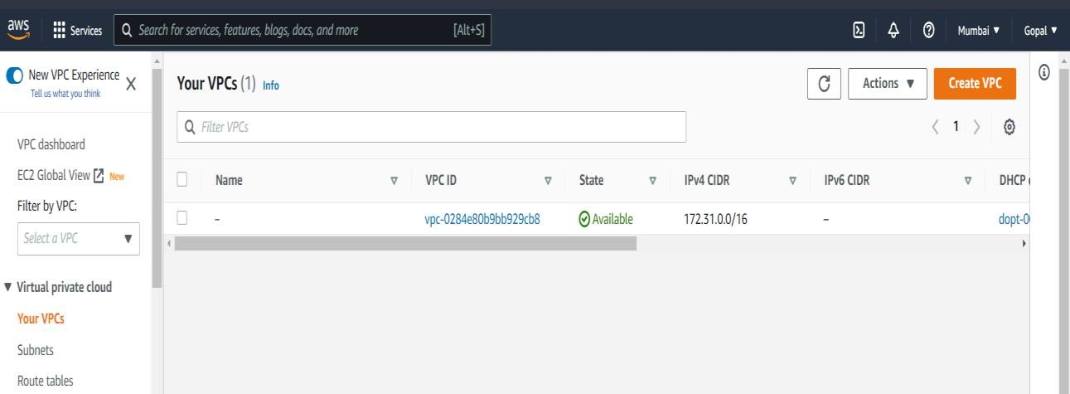

**Step 2:** We have to create our own custom VPC. So click on create VPC. Give name tag and also give IPv4 CIDR as per your choice.

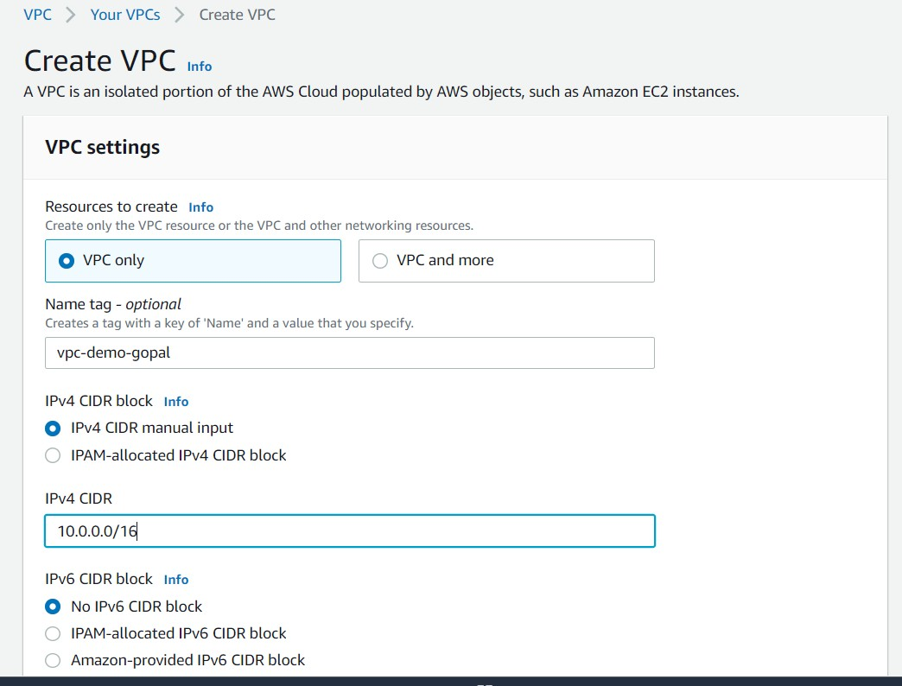

**Step 3:** click as things as default and then click on create VPC. Once you click that below interface will appear.

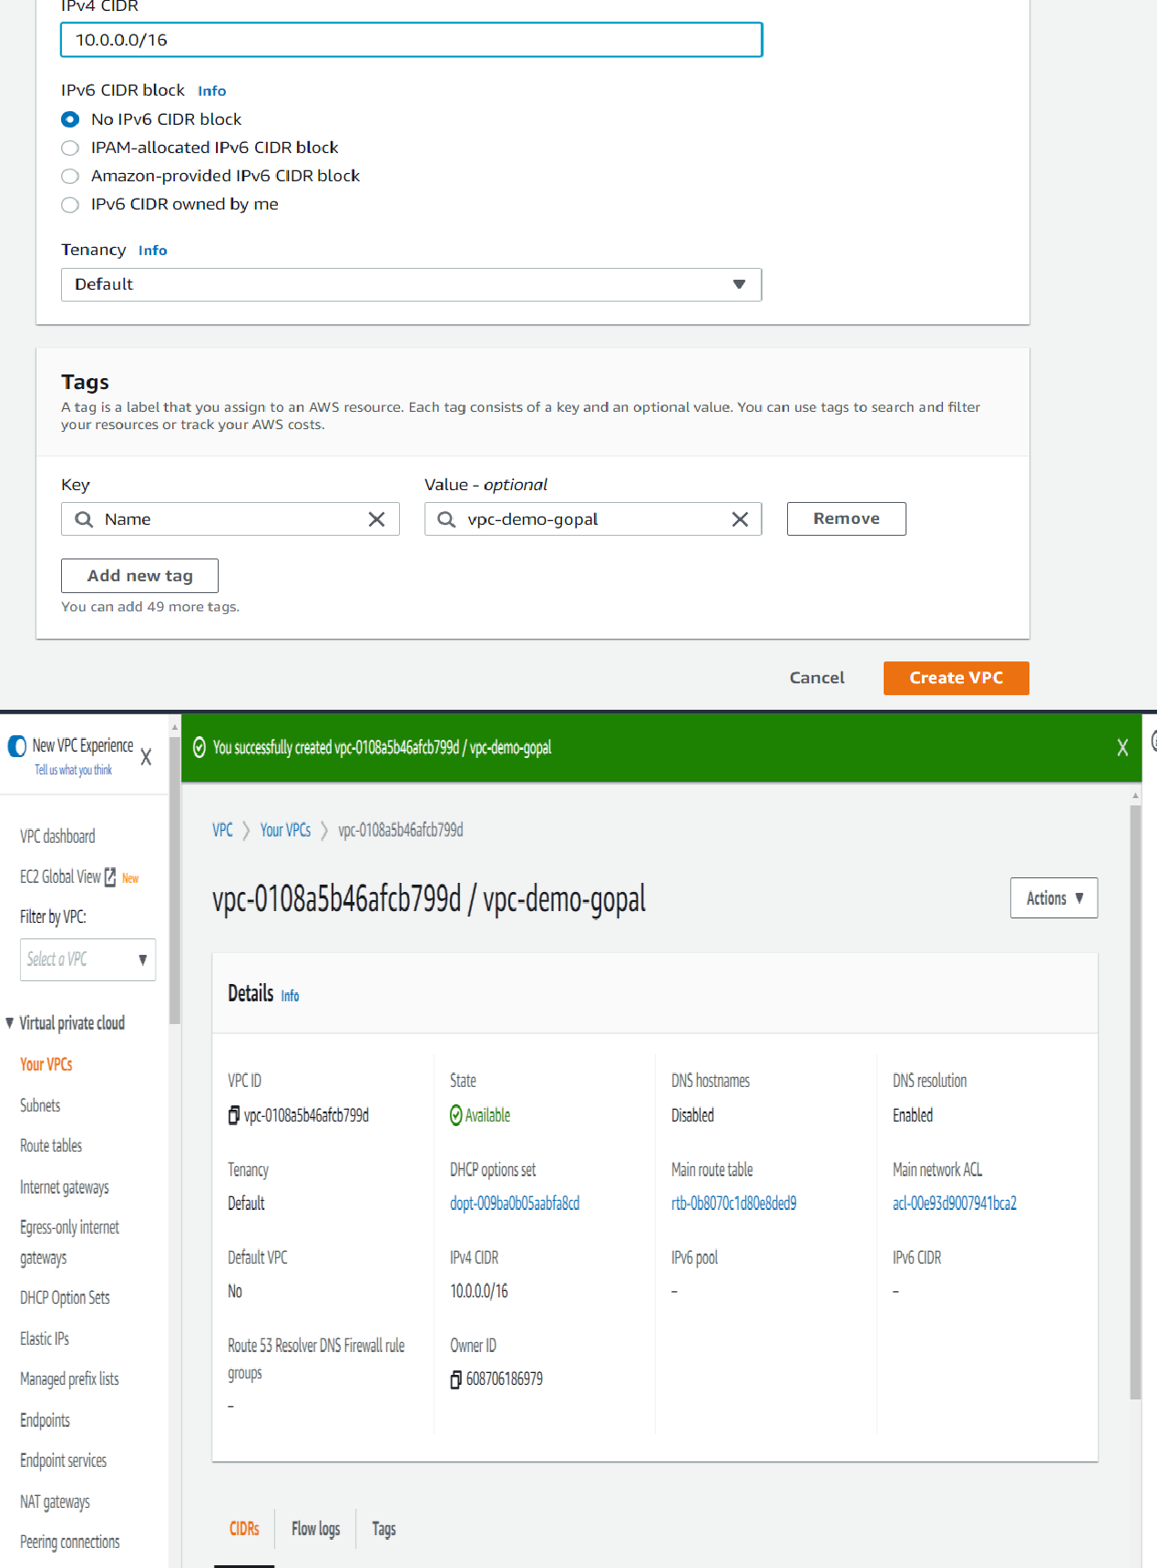

**Step 4:** Now lets create small network range of VPC known as subnet. So click on Subnet, then click on CREATE SUBNET.

Select the custom VPC you created and give the range of IP address.

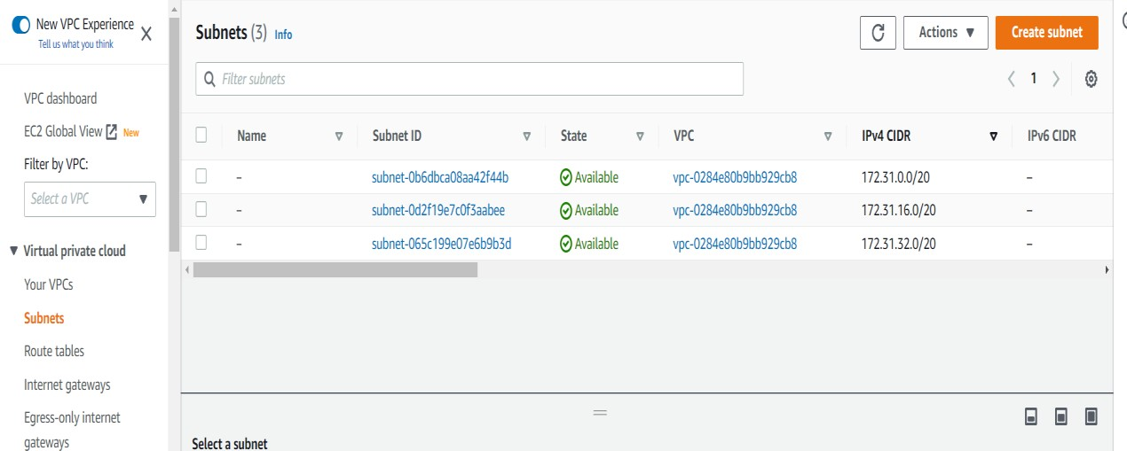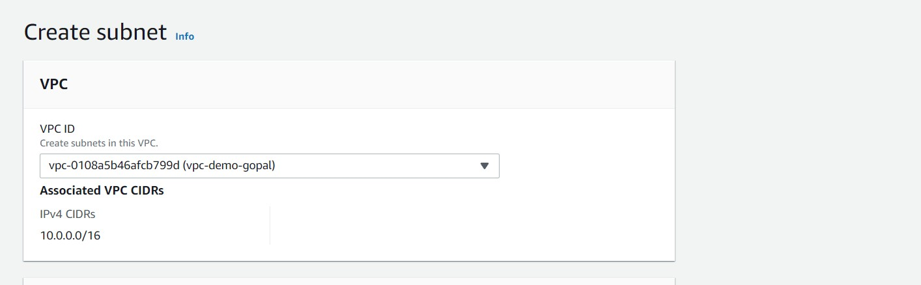

**Step 5:** Now define the name of your subnet, choose AZ and Give

the range of IP address for your subnet. Then click on Create

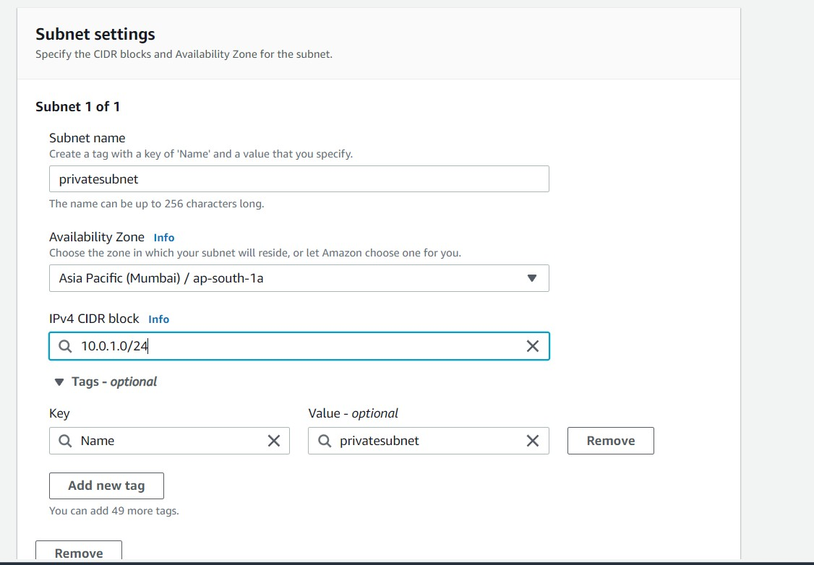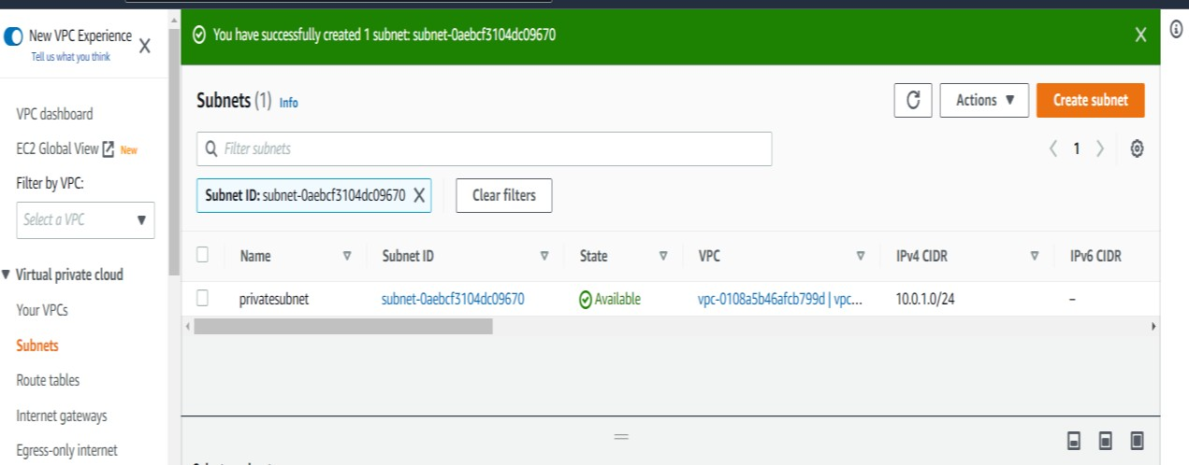

**Step 6:** Now lets create Route table for our subnet. Click on Route

table then click on Create Route table.

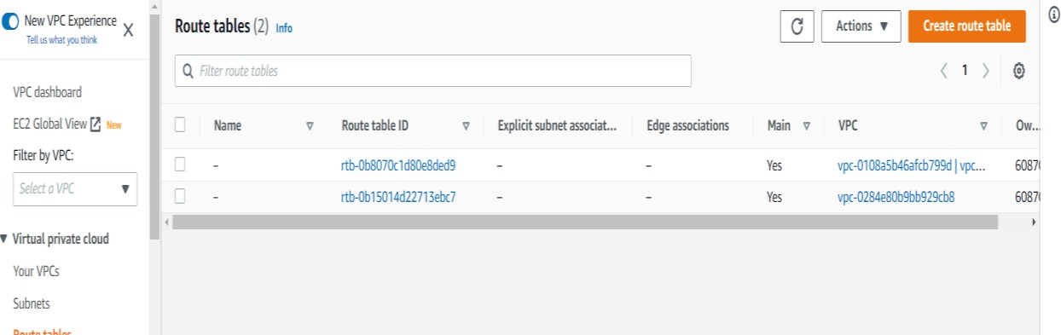

**Step 7:** Now Name your route table. Then select the customed VPC

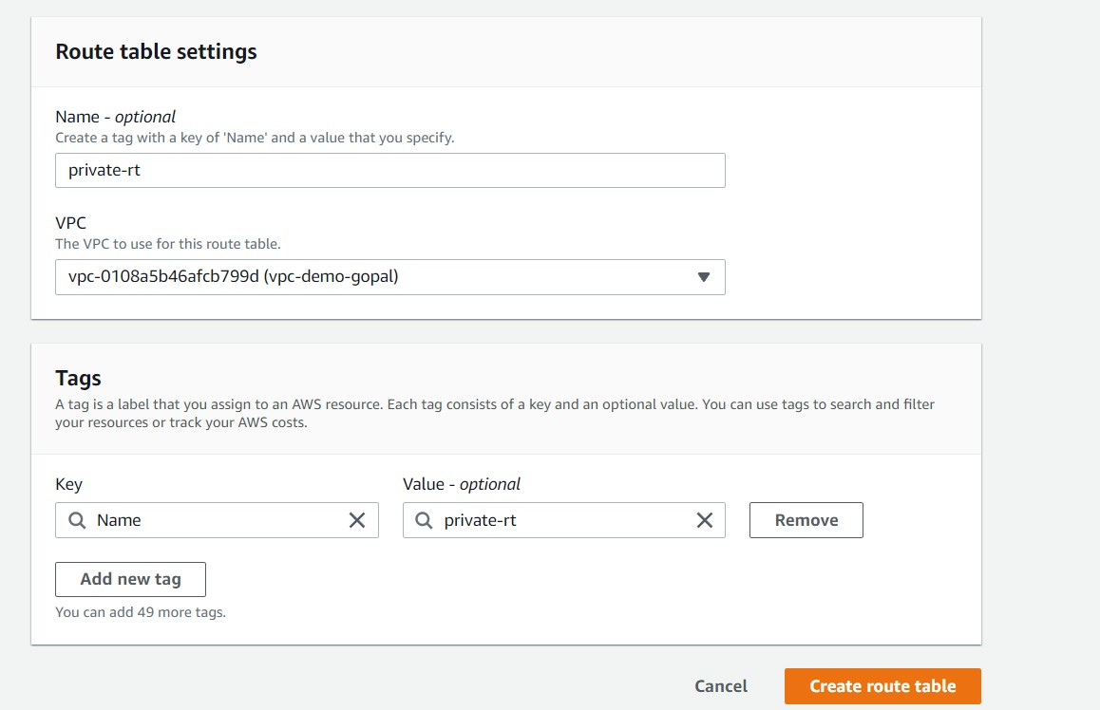and click on create.

**Step 8:** Once your route table is create , we have to know associate

that route table with the respective subnet.

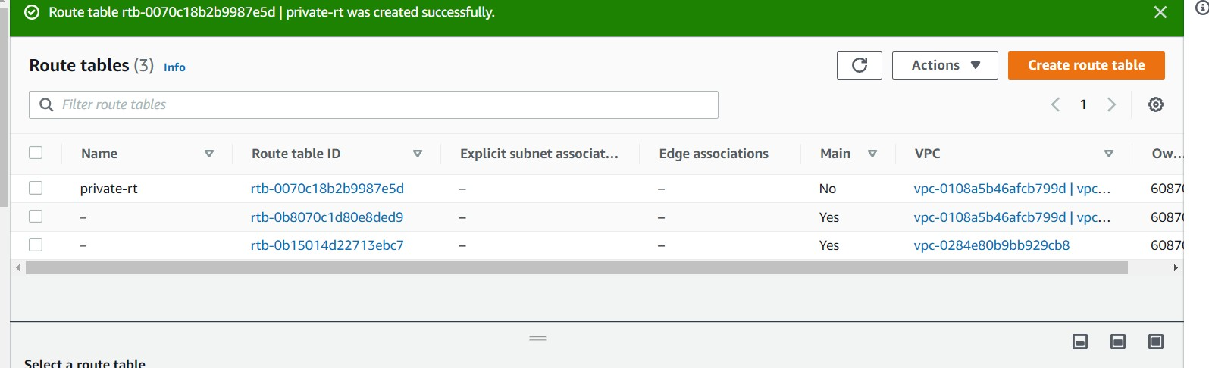

**Step 9:** Choose your Route table then click on subnet association. Then click on edit subnet association

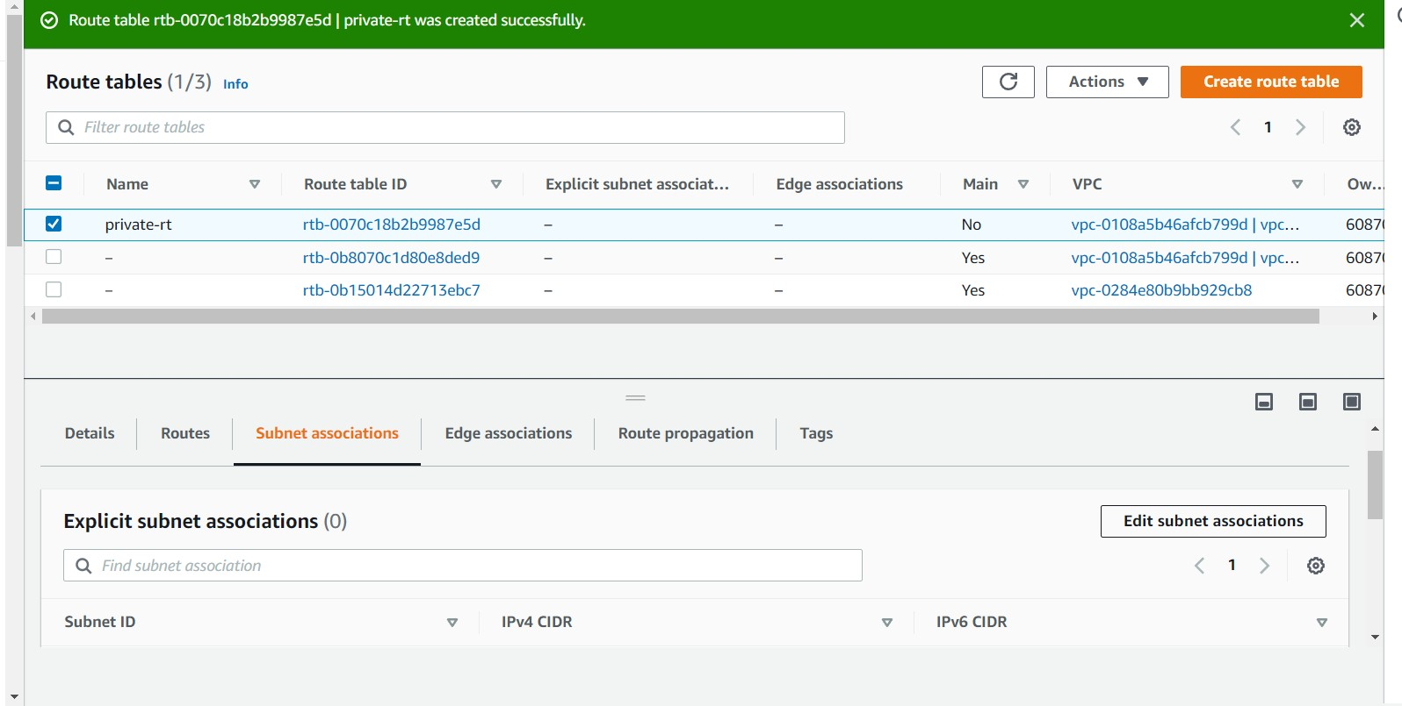

**Step 10:** After that choose subnet with you want to associate then save association

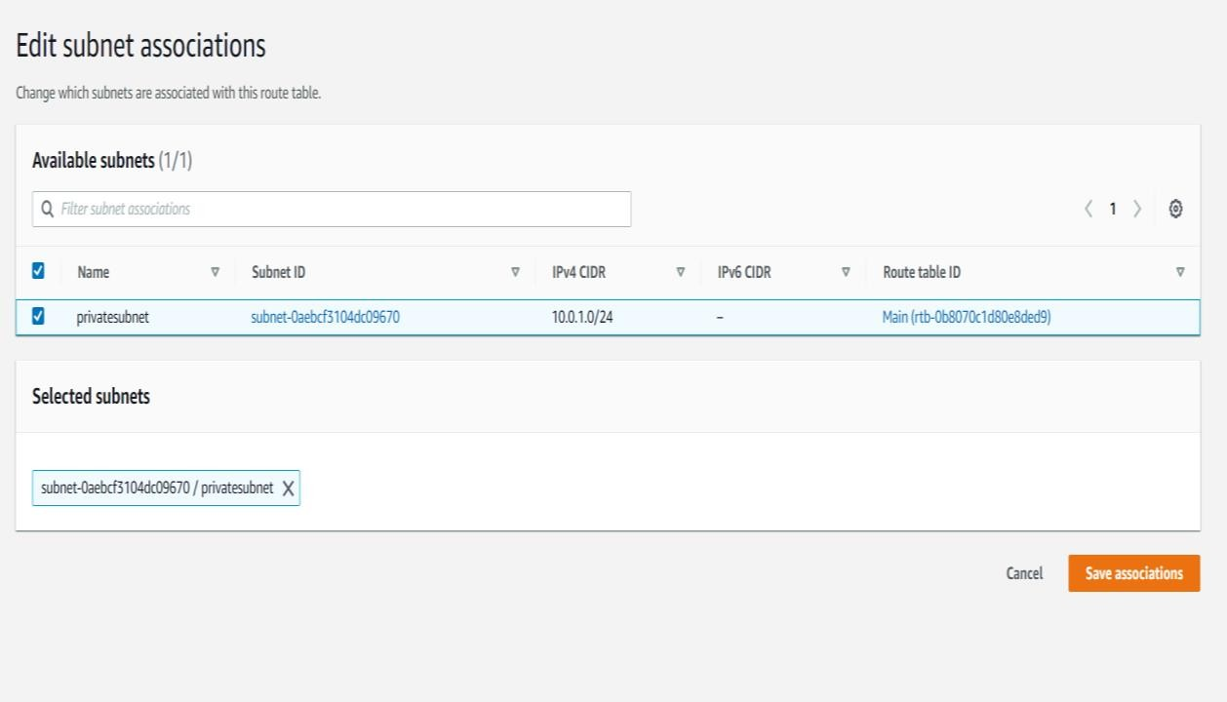

**Step 11:** Now lets create Internet gateway. Click on Internet

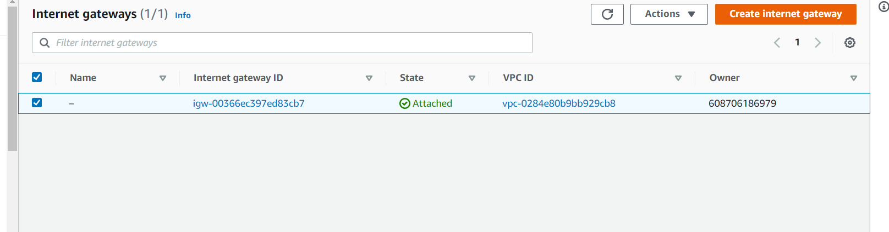gateway from left side.

**Step 12:** Give the name tags and click on Create.

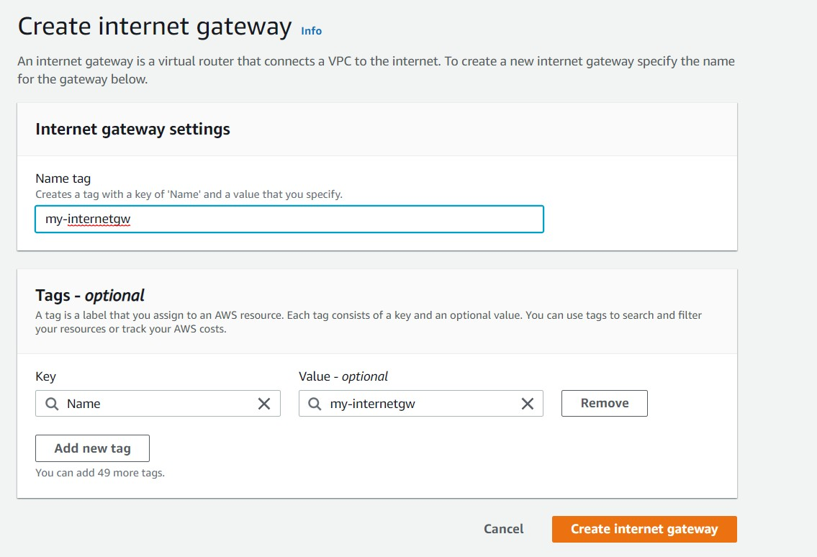

**Step 13:** After that we jave to attach internet gateway to your vpc. so choose your IG and click on action. You can see option attach to VPC. Click that.

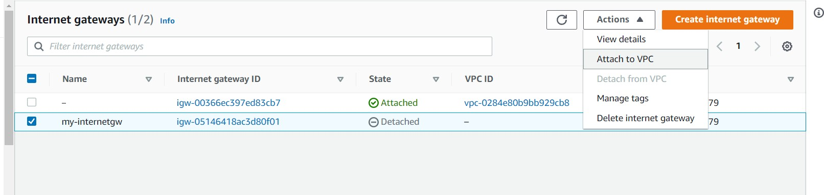

**Step 14:** choose your VPC then click attach Internet gateway

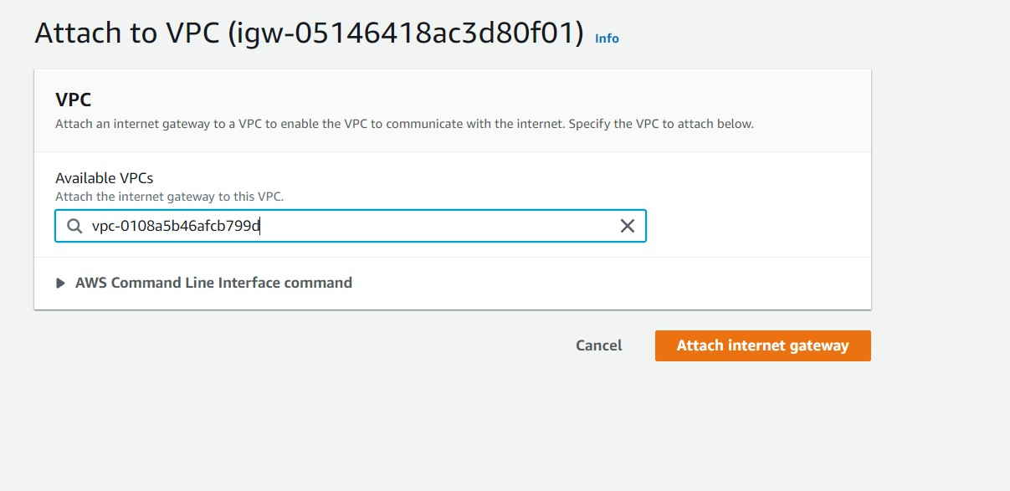

**Step 15:** Once it is attached you will see status as ATTACHED.

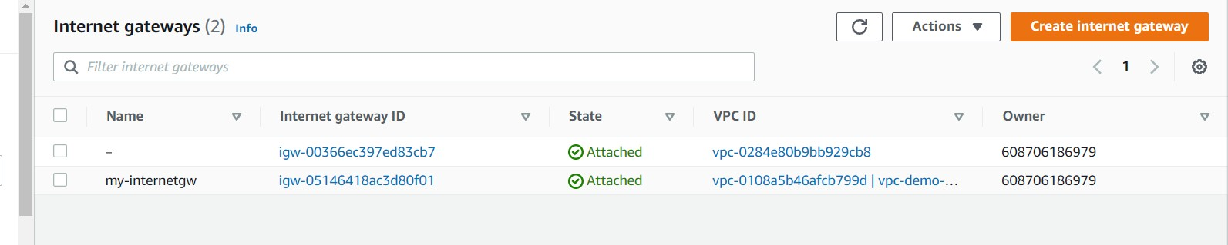

**Step 16:** now you can define internet gateway in route table to associate IG to respective subnet.

Also now you can fire EC2 Instance in your VPC and a lot more things.